Captain Fishing Tournament
10/08/21

Location: Hula Bay
5210 W Tyson Ave.
Tampa, FL 33611
www.hulabayclub.com

SCHEDULE:
7:30 am Registration & breakfast
*Team Captain will check in for group
8:30 am Tournament starts
1:30 pm Lines out of the water
2:00 pm All boats return to Hula Bay
2:30 pm Award ceremony & raffle with lunch buffet and drink tickets for beer.

Deadline for Pre-Registration:
September 8, 2021
*Don’t delay, this tournament will sell out!

Registration Click Here

Guided Boat for up to 3 anglers: $1,500
*All boats will include a Captain with bait and tackle. SUCA will provide cooler with refreshments and snacks.
Sponsorship Opportunities:
Cooler Sponsor: (1) @ $1,500
Lunch Sponsor: (4) @ $1,000
Dry Bag Sponsor: (2) @ $750
Breakfast Sponsor: (1) @ $750
Snack Sponsor: (1) @ $500
Keg Sponsor: (2) @ $500
iAngler App Sponsor: (1) @ $500
General Sponsor: (40) @ $250
*All sponsors will be advertised with logos in expected areas, on main banner and in announcements.

Donations for Raffle Appreciated!
Questions Contact: tmannix@suca.org
Theresa Mannix, Executive Director
727-600-7158
P.O. Box, 21424, Tampa, FL 33622

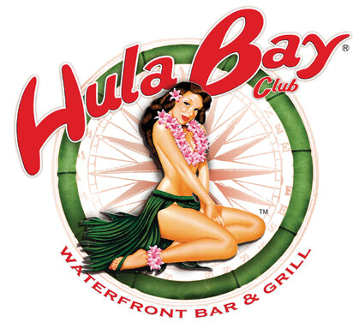

Shirts:
All anglers will receive a Columbia Fishing Shirt. We will order both Male and Female Shirts so please specify size and gender when ordering. If you do not note a size shirt an XL Men’s will be ordered for you at the deadline date.
Award Categories will include:
Biggest Snook
Biggest Redfish
Biggest Trout
*Must be submitted and approved with iAngler App and must use measuring tape and token provided.
Thank you to MWI Pumps for being our Title Sponsor!

