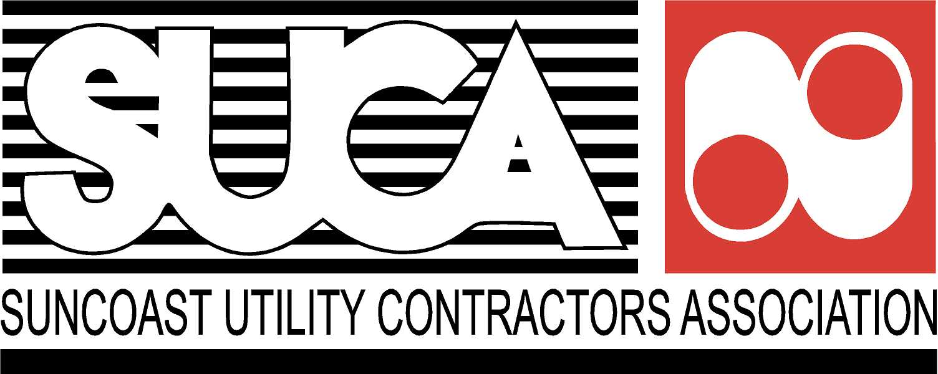

The Suncoast Utility Contractors Association presents the Red Cross Adult CPR, FIRST AID & AED TRAINING CLASS. This training class meets OSHA Guidelines for First Aid Programs and combines lecture, interactive video demonstrations featuring emergency scenarios that are likely to occur in a variety of environments and hands-on training to teach participants lifesaving skills. Upon completion of the course, Red Cross certification cards will be issued and are valid for 2 years.

RED CROSS ADULT
CPR, FIRST AID & AED TRAINING

Friday, July 14, 2017
Registration: 1:45pm
Class Time: 2:00pm – 4:30pm

Dallas 1 Construction
Learning Center (Back of Office Building)
10328 Main Street
Thonotosassa, FL 33592

- First Aid: Participants will learn to recognize and care for a variety of first aid emergencies, such as burns, cuts and scrapes, sudden illnesses, head, neck and back injuries, and heat and cold emergencies
- CPR Adult: Participants will learn how to perform CPR and care for breathing and cardiac emergencies in adults
- AED: Participants will learn how to use Automatic External Defibrillators

Course Instructor will be Roger Greenleaf of Safety Compliance & Training.

Space is limited to the first 30 attendees. Reservations are on a first come, first serve basis.
SUCA reserves the right to cancel the seminar if a 10 person minimum is not met.

Please register the following people for the Friday, July 14, 2017 CPR / First Aid / AED Training Class:

SUCA Member = $60.00 Non-Member $75.00

Name (to send certificate to): Phone:
Company: Fax:
Mailing Address:
City: State: Zip:

Registrant Name: | Registrant Name:

Suncoast Utility Contractors Association
P.O. Box 21424, Tampa, FL 33622
Phone: 813/355-4879 Fax: 813/355-4883
www.suca.org mtjader@suca.org

